HOW ORGANISMS AFFECT EACH OTHER

• Competition - occurs when different organisms need the same resource and there is a limited amount.
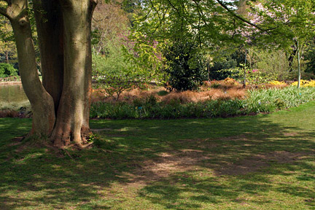
e.g. Grass and a tree compete for light - the grass does not grow very well in the shade of the tree.

Territories are established by animals to ensure animals have enough food, shelter, water and nesting sites. They defend these areas from intruders.

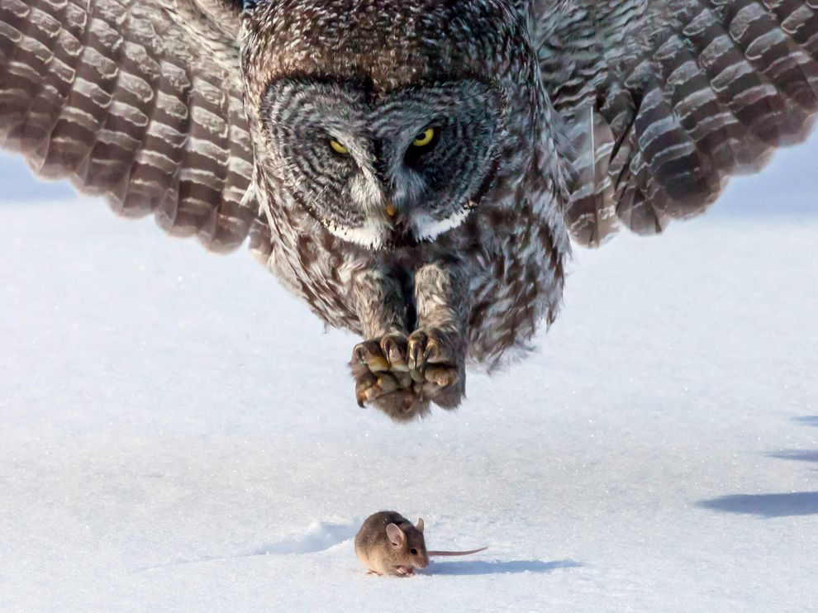
• Predation - one organism eats another.

e.g. Owl (predator) feeds on mice (prey).

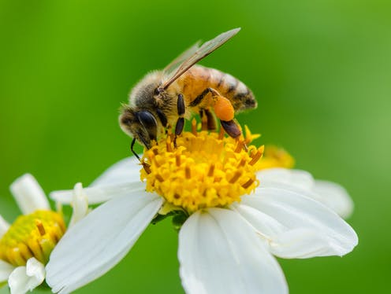
• Mutualism - relationship where two organisms live closely together to help each other.

e.g. Sheep have micro-organisms in their gut to digest cell walls in the plant material they eat. The sheep survives, as do the organisms.

Flowers are pollinated by insects and birds. The flowers produce seeds and the animals receive pollen or nectar as food.

• Parasitism - an organism lives in or on another, causing harm to the host organism.
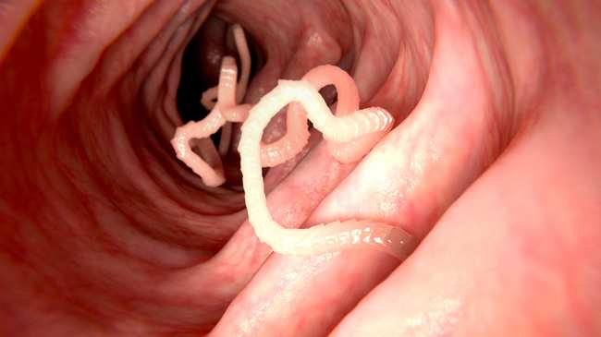
e.g. Tapeworms live in the human intestine, absorbing food to grow but making the human sick.

Ticks and fleas feed on the blood of animals by burrowing into their skin.

• Commensalism - relationship where one organism benefits and the other is unharmed.
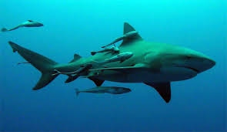
e.g. Remora fish stick to sharks and feed on the scraps left by the shark when it feeds. The shark is unaware of the fish and is unharmed.

